

Version: 4.0.0

Published date: September 2023

Copyright © 2023 by ESW. All rights reserved. Information contained herein is subject to change without notice.

Pricing Advisor Version 4 (Pav4) INTEGRATION GUIDE



**SFCC - ESW Cartridge**

+

Contents

**1** **Pricing Advisor v4 upgrade** 3

1.1 Workflow Diagrams 3

1.1.1 Impacted areas 4

**2** **Pav4 Configuration** 4

2.1 Import Metadata 4

2.1.1 Import system objects 4

2.1.2 Import custom object 5

2.2 Import Service 5

2.3 Run Pricing Feed Job 5

# **Pricing Advisor v4 upgrade**

This is the upgrade guide from Pricing Advisor v3 to Pricing Advisor v4. The main benefits of using PAv4 are as follows:

* Allow use of multiple rounding, adjustments, estimated duty, and estimated tax rules based on different product categories.
* Allow retailers to configure multiple currency displays based on different product categories.
* Improved shopper experience.
* Increase international sales conversion.
* Product reach is further enhanced.
  1. Workflow Diagrams

The integration workflow diagram is as follows:

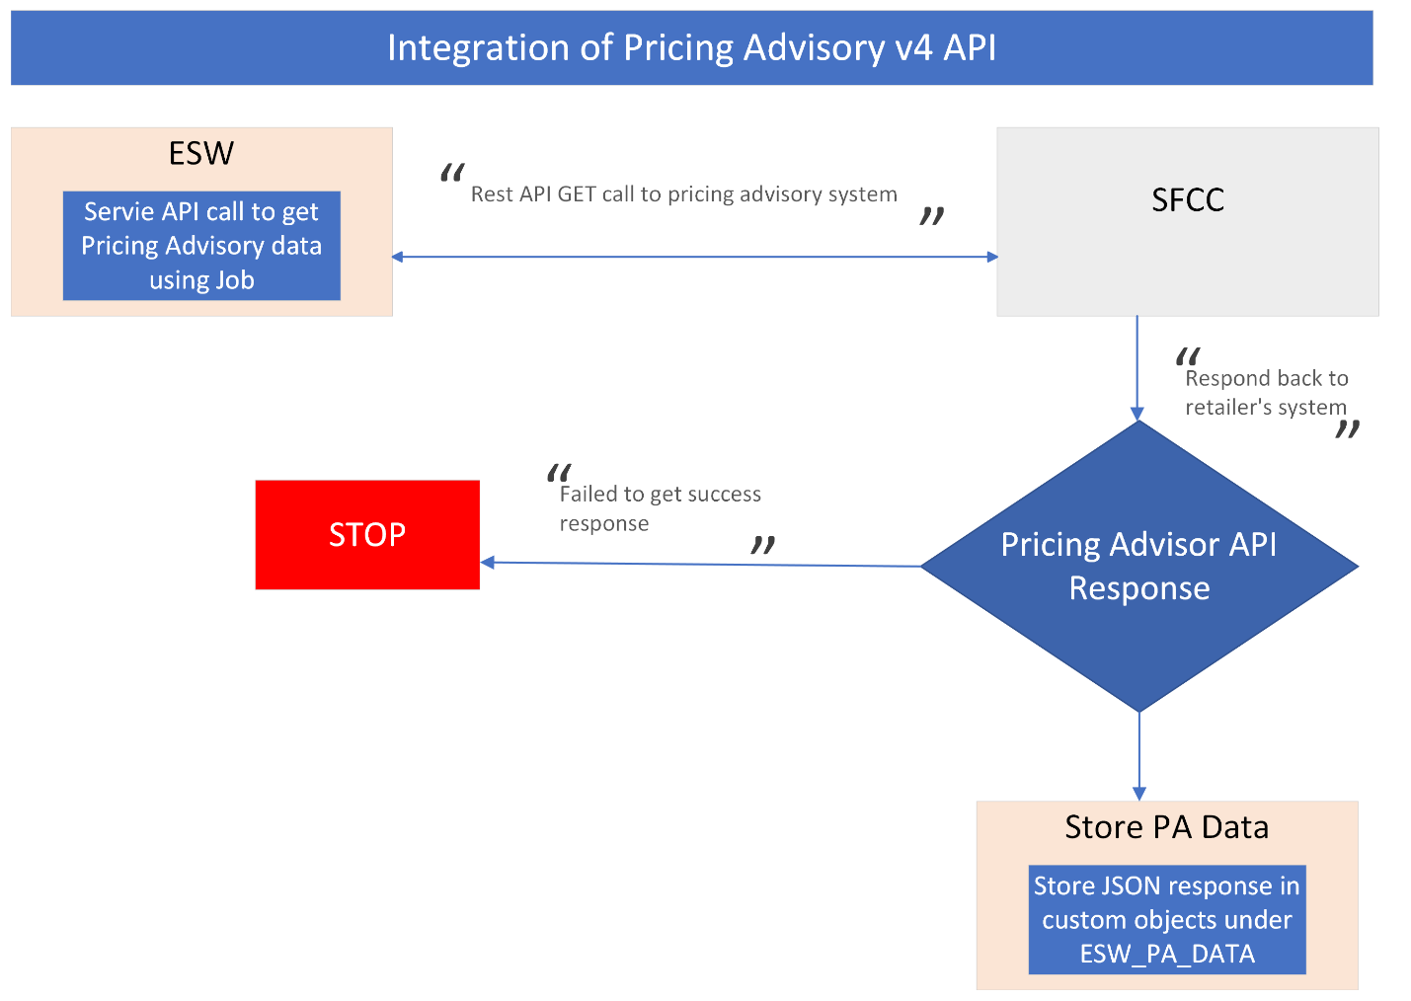

* + 1. Impacted areas

It will impact following areas:

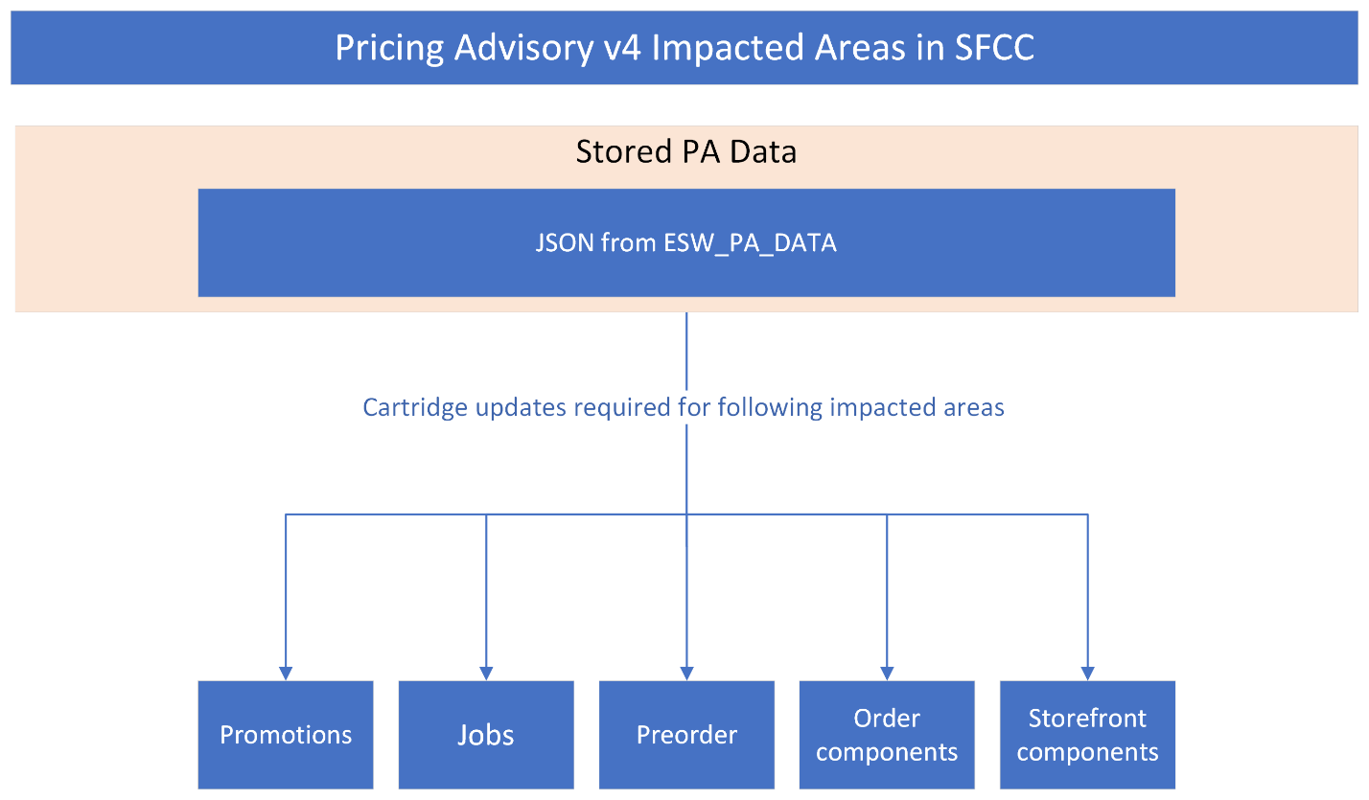

# **PAv4 Configuration**

* 1. Import Metadata
     1. Import system objects

Import Site Preference level custom attributes (systemobjects.xml) from **link_eshopworld\sitesdata\meta.**

The Following attribute will be presented in ESW Pricing Configuration:

* **ESW Pricing Advisor Version**: This attribute will be used to select pricing advisor version. Retailer can select PAv4 or PAv3 from the options. PAv3 is the default option.
  + 1. Import custom object

Import custom attributes (customobjects.xml) from **link_eshopworld\sitesdata\meta. This will create custom object ESW_PA_DATA in custom object editor** 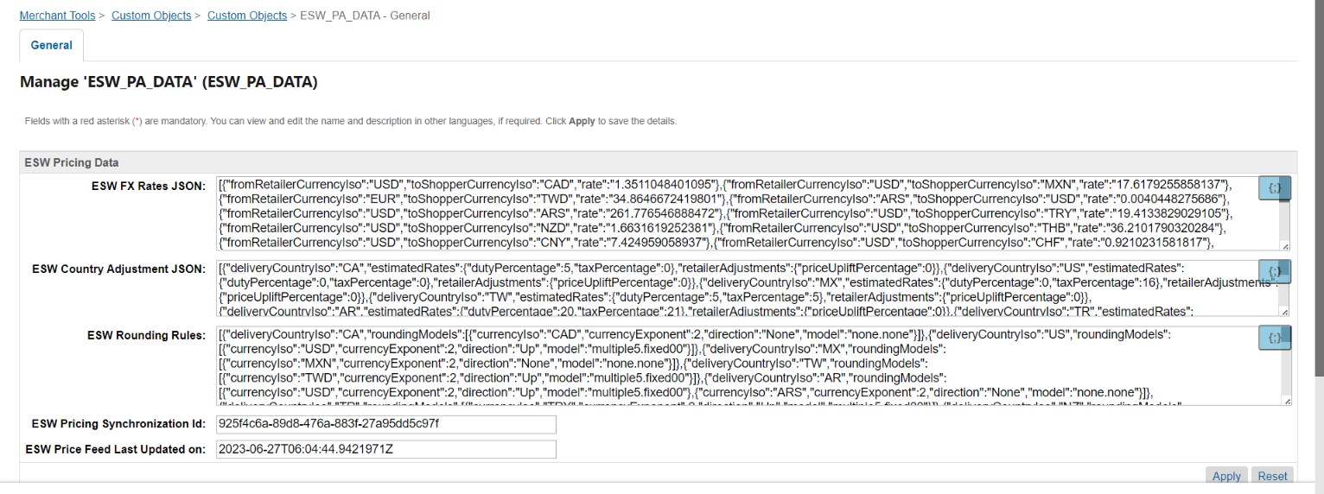

* 1. Import Services

Import services from **link_eshopworld\sitesdata\services.xml**. This will introduce a new service (EswPriceFeedService) for PAv4. Attached credentials and profile with this service will be:

* EswServiceProfile
* EswPriceFeedCredentials

Please fill in EswPriceFeedCredentials with your credentials.  
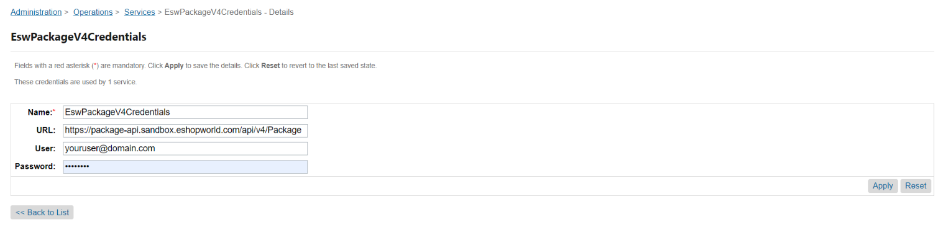

* 1. Run Pricing Feed Job

Import jobs from **link_eshopworld\sitesdata\jobs.xml**. This will create a job “eswRetailerPricingFeed”. This job will be responsible for fetching PA data from the PA service and save in custom object ESW_PA_DATA, as shown in 2.1.2

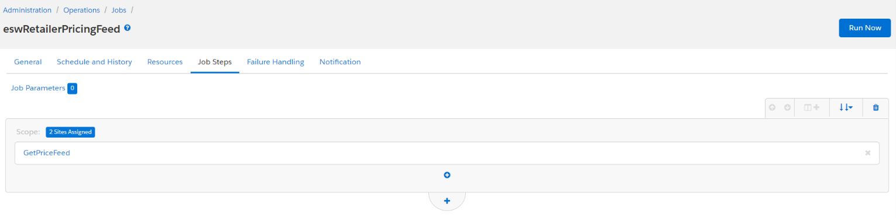

This PA data will use to convert pricing from retailer’s base currency to the shopper’s currency.

Note: Before running this job please make sure following:

* Service (EswPriceFeedService) correctly configured and up
* Site preference (**ESW Pricing Advisor Version) is correctly configured**
* **ESW_PA_DATA is available in custom objects**